**Lab 03 – Spectral Indices**

## Background

The objective of this lab will be to understand how to generate a spectral index from imagery using GEE.

Spectral indices are based on a cover types differential reflectivity of electromagnetic energy of different wavelengths.  Spectral indices are designed to exploit these differences between wavelengths to estimate the amount of that cover type on the earth’s surface.

Take vegetation, for instance. Vegetation reflects light differently depending on wavelength. It absorbs most of the visible light for the photosynthetic process, but reflects a large amount of near infrared (NIR) light. The two images below are two spectral bands taken from the same Sentinel 2 image collected on July, 9, 2020. You can easily tell that the red band is heavily absorbed by vegetation while that same vegetation reflects NIR light. It’s this contrast between spectral bands that forms the basis of all spectral indices.

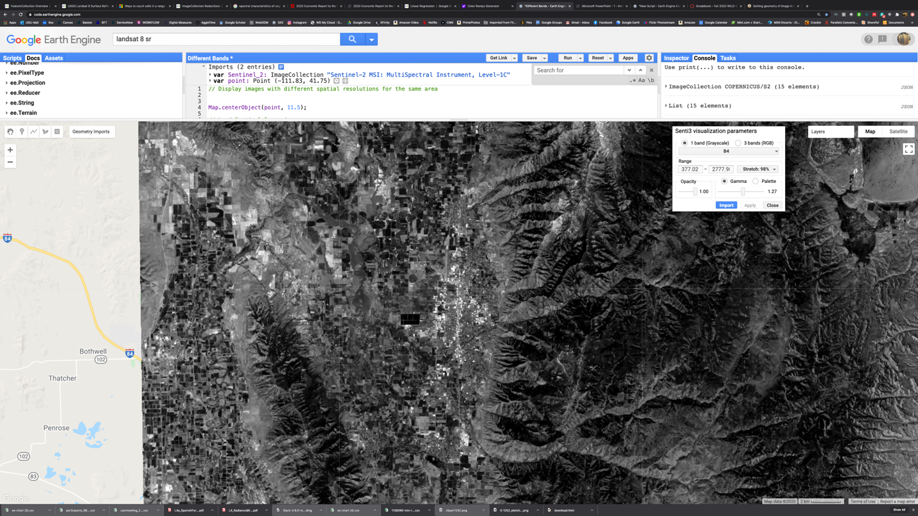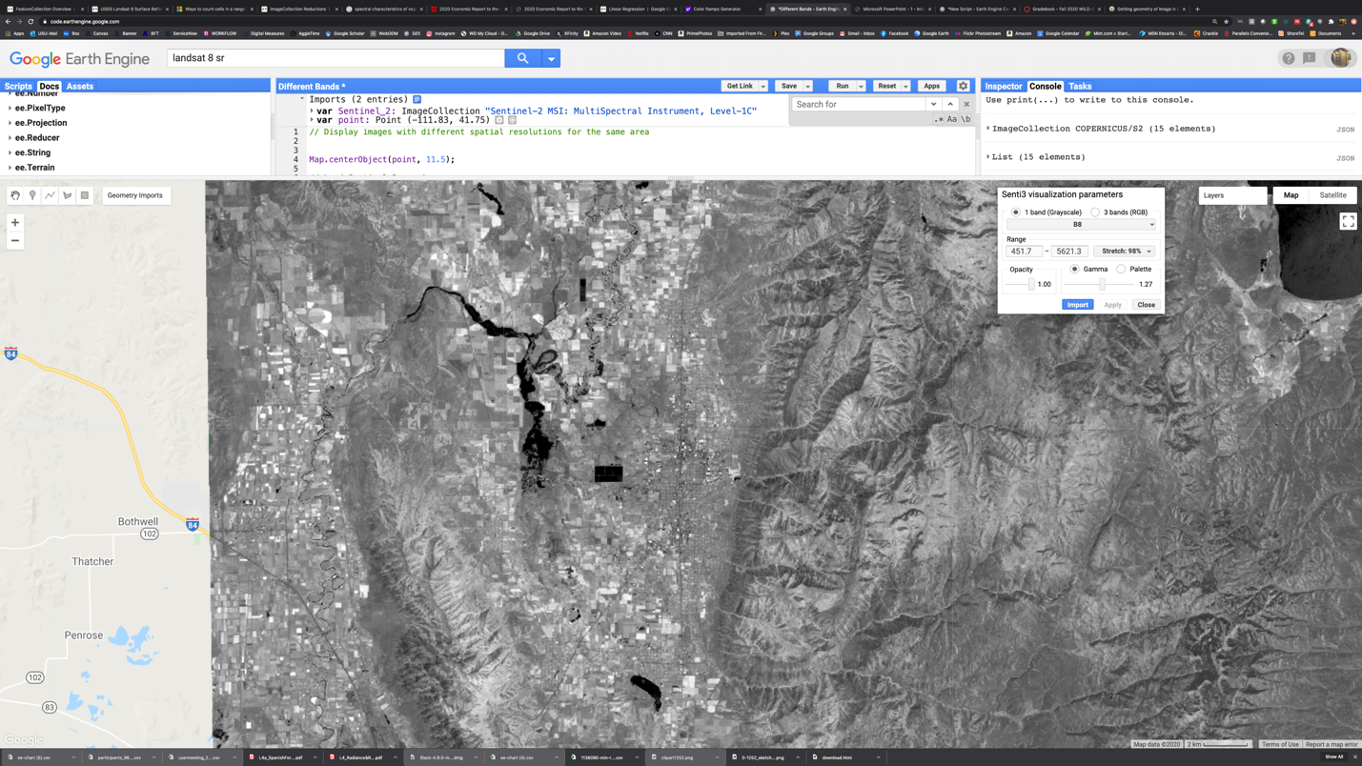

**Red**

**NIR**

In fact, vegetation has multiple points along the EM spectrum that we can use to generate a spectral index. By taking advantage of the chlorophyl absorption of red light and the leaf tissue reflection of NIR light, we can map the relative abundance of vegetation across the landscape.

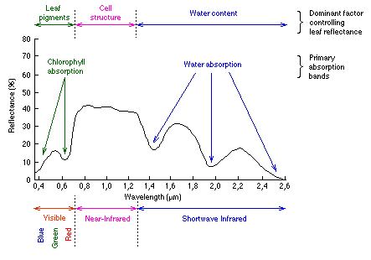

https://www.researchgate.net/figure/Reflectance-spectrum-of-different-materials_fig5_221915805

Also, by using the reflectivity of NIR light contrasted with the absorption of shortwave infrared by water, we can estimate the leaf water content and get an idea of plant water stress.

Nearly all (with some notable exceptions) spectral indices use a basic normalized difference formula which has the form:

Where X and Y represent the two spectral bands that contrast with one another for a given land cover type.

(X-Y)

(X+Y)

The normalized difference formula has a potential output range of -1 to 1. Therefore, if X = Y, then the output is 0. If Y = 0 and X > 0, then the output is 1, and alternatively, if X = 0 and Y > 0, then the output is -1.

Let’s take the vegetation example and use the image I’ve pasted below:

I sampled the green agricultural field in the center of the image using the “Inspector” tab in GEE and found that it had the following reflectance values for the Red, and NIR bands:

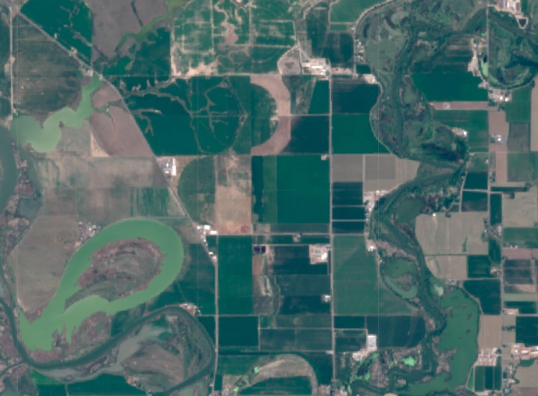

x

x

RED: 416

NIR: 4422

Arguably, the most common normalized difference index in remote sensing is the Normalized Difference Vegetation Index (NDVI). You’ve used this before and It has the following format:

(NIR-Red)

(NIR+Red)

If we substitute the value for our image into the formula, we get:

(4422-416)

(4422+416)

**=**

4006

4838

**=**

**0.828**

If I sample the field directly east where there is no apparent vegetation (x), I get these values for the Red and NIR:

RED: 1078

NIR: 2516

Substituting those values in our formula, the NDVI = **0.400**. NDVI values above 0 indicate vegetation. Therefore, even though this field looks bare, there is something growing on it. We just can’t detect it visually. If I change the band combination from “true color” to a “NIR false color composite”, we can see that the fallow field is a little “pink” indicating some vegetation.

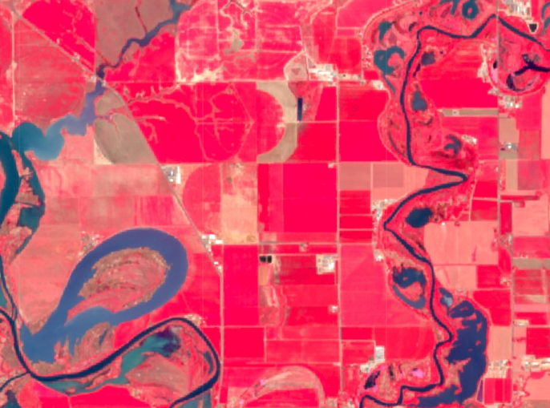

x

If I sample the water in the image, the Red and NIR values are 616 and 583 respectively. Plugging those values in our NDVI formula, we get -0.027. Water has a negative NDVI consistent with the spectral properties of water (more Red reflectance than NIR).

## Normalized Difference in GEE

There are a number of ways in GEE to calculate a normalized difference index.

The easiest way is to use the built-in function called “normalizedDifference(bandNames)”. The syntax is pretty simple:

**var** output = myImage.normalizedDifference([‘X’,’Y’]);

Where:

output = the name of your output image

myImage = your input image (***must be an image, not an image collection***)

X = the spectral band name that needs to be to the left of the equation

Y = the spectral band name that needs to be to the right of the equation.

For the NDVI using Landsat 8 imagery, the command looks like this:

**var** output = myImage.normalizedDifference([‘B5’,’B4’]);

For the NDVI using Sentinel 2 imagery, the command looks like this:

**var** output = myImage.normalizedDifference([‘B8’,’B4’]);

I’ll use Landsat 8 for this example. Feel free to use any of the other Landsat platforms, Sentinel 2, or any other image collection where there is a NIR and Red band.

1. Search for the image collection you want to use and it.
2. Go to any location on the Earth and use the to locate a point of interest to filter the collection with.
3. Filter your image collection by date. Pick a date range in your part of the world when vegetation is actively growing, so if you’re in the southern hemisphere, then maybe November – February, for instance.
4. Filter the image collection by location using your point geometry, sort by cloud cover, and then select the first image.
5. Display the image on the screen.

*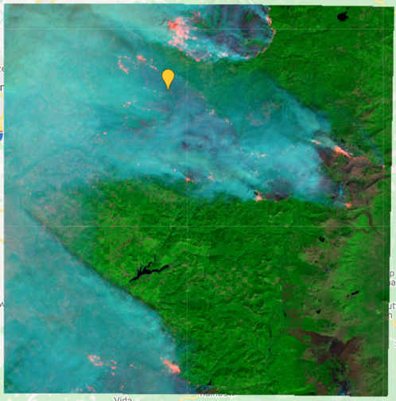I decided to go to the Portland area using the Sentinel 2 Level-1C image collection. I restricted the dates to focus on the images collected in Sept. of 2020 and found one that captured a bunch of fires (id: COPERNICUS/S2/20200909T185929_20200909T191047_T10TEQ). Technically it’s cloud free even though the medata showed 20% cloud cover.*

1. Generate the NDVI for your image and display it
   1. **var** ndvi = myImage.normalizedDifference(['B8','B4']);
   2. Map.addLayer(ndvi,{min: -1, max: 1},'NDVI');
   3. Sentinel NIR = B8 and Red = B4. Yours might be different.

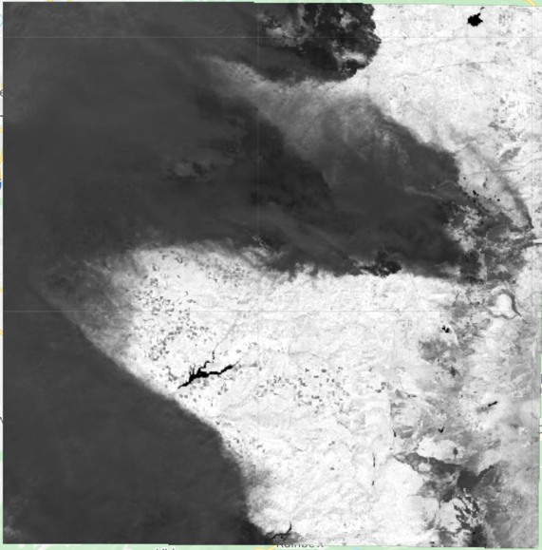Here’s the NDVI output. Brighter areas are greener than darker areas.

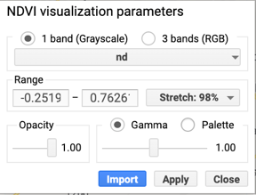Click on the  button at the top right of the map display, then click on the  gear wheel next to your NDVI image to get the display parameters.

Change the stretch from ‘Custom’ to ‘Stretch: 98%’ and ‘Apply’ to improve the image visual quality.

## [Normalized Difference Burn Ratio](http://un-spider.org/advisory-support/recommended-practices/recommended-practice-burn-severity/in-detail/normalized-burn-ratio#:~:text=The%20Normalized%20Burn%20Ratio%20(NBR,shortwave%20infrared%20(SWIR)%20wavelengths.) (NBR):

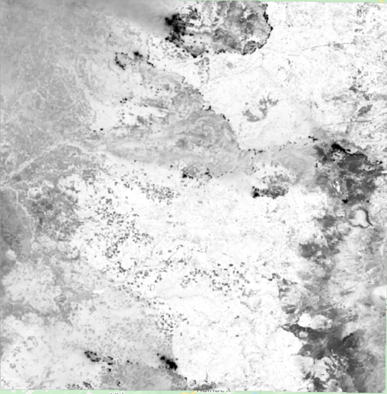The NBR is another common normalized difference index and takes advantage of the increased reflectivity of surface carbon in the shortwave IR (SWIR) in contrast with the lack of reflectivity in the visible and/or NIR bands. The general structure of this index is:

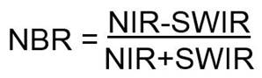Exactly the same as the NDVI, except we are using different spectral bands. The link tied to the section heading above will send you to a web site that describes the index in more detail.

Using your image, generate the NBR using the same function as with the NDVI (assuming you found one with fire scars), if not, then feel free to use the one that I used:

**var** image = ee.Image('COPERNICUS/S2/20200909T185929_20200909T191047_T10TEQ');

Remember to use the correct bands if you’re using Landsat 8, then SWIR = ‘B7’ and NIR = ‘B5’. For Sentinel, it’s ‘B12’ and ‘B8A’.

**var** ndvi = myImage.normalizedDifference(['B8A','B12']);

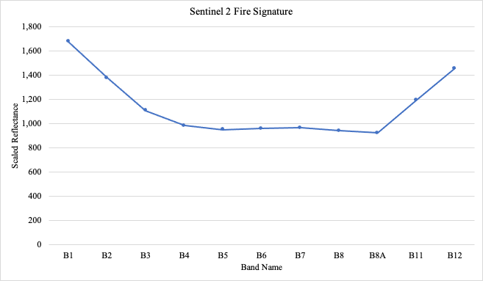In this case, the fires and burned areas look darker than the unburned areas. The figure to the left shows the spectral signature for one of the fire pixels. Notice the difference between the SWIR (B12) and NIR (B8A) for Sentinel 2. The high B1-B4 (visible) is due to smoke reflectivity.

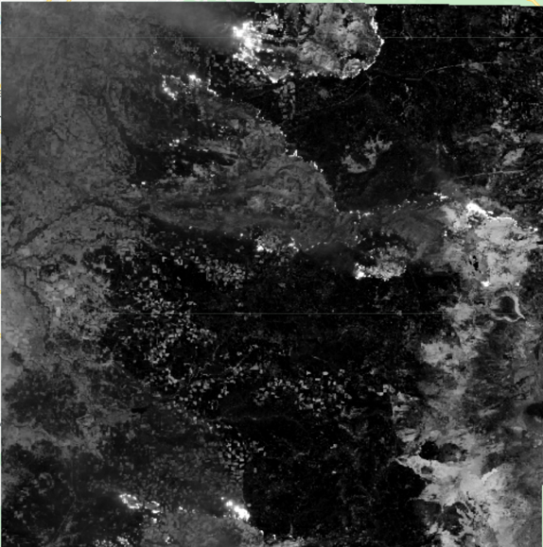One thing that you need to be aware of is that the order of the bands in the formula matters, but mostly due to convention.

Here’s the same fire index but I’ve swapped the band order in the formula from ['B8A','B12'] to ['B12','B8A']. The image comes out in reverse with burned areas in a lighter color than non-burned.

Normalized difference indices are generated for specific purposes such as burned area detection, vegetation/soil moisture, snow, etc. A number of them use the same spectral bands, but applied to different surfaces.

For instance, the Normalized Difference Water Index (NDWI) is identical to the Normalized Difference Soil Index, except that the order of the bands are switched. Basically, an index may be developed for a specific purpose, but can also be useful in another. Image context is important.

Other Normalized Difference Indices:

Now that you know how to operate the normalizedDifference function, here are a few other indices. Also, there’s no reason why you can’t develop your own if you can determine if the feature you are interested in has a consistent “contrast” between spectral bands.

**Normalized Difference Water Index (NDWI)**

NDWI = (*NIR* – *SWIR1*) / (*NIR* + *SWIR1*)

**Normalized Difference Water Body Index (NDWBI)**

NDWBI = (*Green* – NIR) / (*Green* + *NIR*)

**Normalized Difference Bare Index (NDBI)**

NDBI = (*SWIR1* - *NIR*) / (*SWIR1* + *NIR*)

**Normalized Difference Snow Index (NDSI)**

NDSI = (*green* - *SWIR*) / (*green* + *SWIR*)

**Q1.** Generate normalized indices for the NDVI, NBR, NDWI, NDWBI, NDBI, and NDSI.

* Display screen grabs of your original image using a band combination of your choosing alongside the normalized difference output.
* Explore each output image to understand what each index is doing. No question for me to ask here. Many of you will be using indices like these for your project work and it will pay to try to understand them. You can use the inspector to query the pixel values
* Provide the link to your script that generates all of these indices (can be one script)

Q2. For each index that you generate, create a color palette in the visualization parameters block that is appropriate for that index.

For instance, if you want to colorize the NDVI output, then:

**var** NDVIvisParam = {

min: -0.2,

max: 0.8,

palette: ['white', 'green']

};

The min and max values I estimated through trial and error. The **['white', 'green']** will set -0.2 to white and 0.8 to green with all other values ramped between white and green. You can put as many colors as you want. For instance, **[‘red’,'white', 'green']** will set -0.2 to red, then ramp to white at the mid-point between -0.2 and 0.8 to white and then ramp to green at 0.8.

Choose a ramp that you think best fits the index.

# Appendix

Selection of 80 Spectral Indices from <https://github.com/davemlz/awesome-spectral-indices>

(See link for explanation of variables)

|  |  |  |  |
| --- | --- | --- | --- |
| **short_name** | **long_name** | **type** | **formula** |
| BAI | Burned Area Index | burn | 1.0 / ((0.1 - R) ** 2.0 + (0.06 - N) ** 2.0) |
| BAIS2 | Burned Area Index for Sentinel 2 | burn | (1.0 - ((RE2 * RE3 * RE4) / R) ** 0.5) * (((S2 - RE4)/(S2 + RE4) ** 0.5) + 1.0) |
| CSIT | Char Soil Index Thermal | burn | N / (S2 * T1 / 10000.0) |
| NBR | Normalized Burn Ratio | burn | (N - S2) / (N + S2) |
| NBRT | Normalized Burn Ratio Thermal | burn | (N - (S2 * T1 / 10000.0)) / (N + (S2 * T1 / 10000.0)) |
| NDVIT | Normalized Difference Vegetation Index Thermal | burn | (N - (R * T1 / 10000.0))/(N + (R * T1 / 10000.0)) |
| SAVIT | Soil-Adjusted Vegetation Index Thermal | burn | (1.0 + L) * (N - (R * T1 / 10000.0)) / (N + (R * T1 / 10000.0) + L) |
| NDDI | Normalized Difference Drought Index | drought | (((N - R)/(N + R)) - ((G - N)/(G + N)))/(((N - R)/(N + R)) + ((G - N)/(G + N))) |
| NMDI | Normalized Multi‐band Drought Index | drought | (N - (S1 - S2))/(N + (S1 - S2)) |
| NDSI | Normalized Difference Snow Index | snow | (G - S1) / (G + S1) |
| NDSII | Normalized Difference Snow Ice Index | snow | (R - S1) / (R + S1) |
| S3 | S3 Snow Index | snow | (N * (R - S1)) / ((N + R) * (N + S1)) |
| SWI | Snow Water Index | snow | (G * (N - S1)) / ((G + N) * (N + S1)) |
| EBBI | Enhanced Built-Up and Bareness Index | urban | (S1 - N) / (10.0 * ((S1 + T1) ** 0.5)) |
| NDBI | Normalized Difference Built-Up Index | urban | (S1 - N) / (S1 + N) |
| NDBaI | Normalized Difference Bareness Index | urban | (S1 - T1) / (S1 + T1) |
| NHFD | Non-Homogeneous Feature Difference | urban | (RE1 - A) / (RE1 + A) |
| ARVI | Atmospherically Resistant Vegetation Index | vegetation | (N - (R - (R - B))) / (N + (R - (R - B))) |
| ATSAVI | Adjusted Transformed Soil-Adjusted Vegetation Index | vegetation | sla * (N - sla * R - slb) / (sla * N + R - sla * slb + 0.08 * (1 + sla ** 2.0)) |
| BNDVI | Blue Normalized Difference Vegetation Index | vegetation | (N - B)/(N + B) |
| CIG | Chlorophyll Index Green | vegetation | (N / G) - 1.0 |
| CIRE | Chlorophyll Index Red Edge | vegetation | (N / RE1) - 1 |
| CVI | Chlorophyll Vegetation Index | vegetation | (N * R) / (G ** 2.0) |
| DVI | Difference Vegetation Index | vegetation | N - R |
| EVI | Enhanced Vegetation Index | vegetation | g * (N - R) / (N + C1 * R - C2 * B + L) |
| EVI2 | Two-Band Enhanced Vegetation Index | vegetation | g * (N - R) / (N + 2.4 * R + L) |
| ExG | Excess Green Index | vegetation | 2 * G - R - B |
| GARI | Green Atmospherically Resistant Vegetation Index | vegetation | (N - (G - (B - R))) / (N - (G + (B - R))) |
| GBNDVI | Green-Blue Normalized Difference Vegetation Index | vegetation | (N - (G + B))/(N + (G + B)) |
| GDVI | Generalized Difference Vegetation Index | vegetation | ((N ** nexp) - (R ** nexp)) / ((N ** nexp) + (R ** nexp)) |
| GEMI | Global Environment Monitoring Index | vegetation | ((2.0*((N ** 2.0)-(R ** 2.0)) + 1.5*N + 0.5*R)/(N + R + 0.5))*(1.0 - 0.25*((2.0 * ((N ** 2.0) - (R ** 2)) + 1.5 * N + 0.5 * R)/(N + R + 0.5)))-((R - 0.125)/(1 - R)) |
| GLI | Green Leaf Index | vegetation | (2.0 * G - R - B) / (2.0 * G + R + B) |
| GNDVI | Green Normalized Difference Vegetation Index | vegetation | (N - G)/(N + G) |
| GRNDVI | Green-Red Normalized Difference Vegetation Index | vegetation | (N - (G + R))/(N + (G + R)) |
| GVMI | Global Vegetation Moisture Index | vegetation | ((N + 0.1) - (S2 + 0.02)) / ((N + 0.1) + (S2 + 0.02)) |
| IRECI | Inverted Red-Edge Chlorophyll Index | vegetation | (RE3 - R) / (RE1 / RE2) |
| MCARI | Modified Chlorophyll Absorption in Reflectance Index | vegetation | ((RE1 - R) - 0.2 * (RE1 - G)) * (RE1 / R) |
| MCARI1 | Modified Chlorophyll Absorption in Reflectance Index 1 | vegetation | 1.2 * (2.5 * (N - R) - 1.3 * (N - G)) |
| MCARI2 | Modified Chlorophyll Absorption in Reflectance Index 2 | vegetation | (1.5 * (2.5 * (N - R) - 1.3 * (N - G))) / ((((2.0 * N + 1) ** 2) - (6.0 * N - 5 * (R ** 0.5)) - 0.5) ** 0.5) |
| MGRVI | Modified Green Red Vegetation Index | vegetation | (G ** 2.0 - R ** 2.0) / (G ** 2.0 + R ** 2.0) |
| MNDVI | Modified Normalized Difference Vegetation Index | vegetation | (N - S2)/(N + S2) |
| MNLI | Modified Non-Linear Vegetation Index | vegetation | (1 + L)*((N ** 2) - R)/((N ** 2) + R + L) |
| MSAVI | Modified Soil-Adjusted Vegetation Index | vegetation | 0.5 * (2.0 * N + 1 - (((2 * N + 1) ** 2) - 8 * (N - R)) ** 0.5) |
| MSR | Modified Simple Ratio | vegetation | (N / R - 1) / ((N / R + 1) ** 0.5) |
| MTCI | MERIS Terrestrial Chlorophyll Index | vegetation | (RE2 - RE1) / (RE1 - R) |
| MTVI1 | Modified Triangular Vegetation Index 1 | vegetation | 1.2 * (1.2 * (N - G) - 2.5 * (R - G)) |
| MTVI2 | Modified Triangular Vegetation Index 2 | vegetation | (1.5 * (1.2 * (N - G) - 2.5 * (R - G))) / ((((2.0 * N + 1) ** 2) - (6.0 * N - 5 * (R ** 0.5)) - 0.5) ** 0.5) |
| NDREI | Normalized Difference Red Edge Index | vegetation | (N - RE1) / (N + RE1) |
| NDVI | Normalized Difference Vegetation Index | vegetation | (N - R)/(N + R) |
| NDYI | Normalized Difference Yellowness Index | vegetation | (G - B) / (G + B) |
| NGRDI | Normalized Green Red Difference Index | vegetation | (G - R) / (G + R) |
| NLI | Non-Linear Vegetation Index | vegetation | ((N ** 2) - R)/((N ** 2) + R) |
| NRFIg | Normalized Rapeseed Flowering Index Green | vegetation | (G - S2) / (G + S2) |
| NRFIr | Normalized Rapeseed Flowering Index Red | vegetation | (R - S2) / (R + S2) |
| OCVI | Optimized Chlorophyll Vegetation Index | vegetation | (N / G) * (R / G) ** cexp |
| OSAVI | Optimized Soil-Adjusted Vegetation Index | vegetation | (N - R) / (N + R + 0.16) |
| RDVI | Renormalized Difference Vegetation Index | vegetation | (N - R) / ((N + R) ** 0.5) |
| RVI | Ratio Vegetation Index | vegetation | N / R |
| S2REP | Sentinel-2 Red-Edge Position | vegetation | 705.0 + 35.0 * ((((RE3 + R) / 2.0) - RE1) / (RE2 - RE1)) |
| SARVI | Soil Adjusted and Atmospherically Resistant Vegetation Index | vegetation | (1 + L)*(N - (R - (R - B))) / (N + (R - (R - B)) + L) |
| SAVI | Soil-Adjusted Vegetation Index | vegetation | (1.0 + L) * (N - R) / (N + R + L) |
| SAVI2 | Soil-Adjusted Vegetation Index 2 | vegetation | N / (R + (slb / sla)) |
| SIPI | Structure Insensitive Pigment Index | vegetation | (N - A) / (N - R) |
| SeLI | Sentinel-2 LAI Green Index | vegetation | (RE4 - RE1) / (RE4 + RE1) |
| TCARI | Transformed Chlorophyll Absorption in Reflectance Index | vegetation | 3 * ((RE1 - R) - 0.2 * (RE1 - G) * (RE1 / R)) |
| TCI | Triangular Chlorophyll Index | vegetation | 1.2 * (RE1 - G) - 1.5 * (R - G) * (RE1 / R) ** 0.5 |
| TGI | Triangular Greenness Index | vegetation | - 0.5 * (190 * (R - G) - 120 * (R - B)) |
| TRRVI | Transformed Red Range Vegetation Index | vegetation | ((RE2 - R) / (RE2 + R)) / (((N - R) / (N + R)) + 1.0) |
| TSAVI | Transformed Soil-Adjusted Vegetation Index | vegetation | sla * (N - sla * R - slb) / (sla * N + R - sla * slb) |
| TTVI | Transformed Triangular Vegetation Index | vegetation | 0.5 * ((865.0 - 740.0) * (RE3 - RE2) - (RE4 - RE2) * (783.0 - 740)) |
| TVI | Triangular Vegetation Index | vegetation | 0.5 * (120 * (N - G) - 200 * (R - G)) |
| VARI | Visible Atmospherically Resistant Index | vegetation | (G - R) / (G + R - B) |
| WDRVI | Wide Dynamic Range Vegetation Index | vegetation | (alpha * N - R) / (alpha * N + R) |
| WDVI | Weighted Difference Vegetation Index | vegetation | N - sla * R |
| AWEInsh | Automated Water Extraction Index | water | 4.0 * (G - S1) - 0.25 * N + 2.75 * S2 |
| AWEIsh | Automated Water Extraction Index with Shadows Elimination | water | B + 2.5 * G - 1.5 * (N + S1) - 0.25 * S2 |
| MNDWI | Modified Normalized Difference Water Index | water | (G - S1) / (G + S1) |
| NDWI | Normalized Difference Water Index | water | (G - N) / (G + N) |
| WI1 | Water Index 1 | water | (G - S2) / (G + S2) |
| WI2 | Water Index 2 | water | (B - S2) / (B + S2) |